**18. First-Order Predicate Logic (FOPC) Parser**

**Aim:**  
To implement a parser for basic logical expressions.

**Algorithm:**

1. Define basic rules for FOPC syntax.
2. Parse the input logical expression.
3. Validate the syntax using rules.

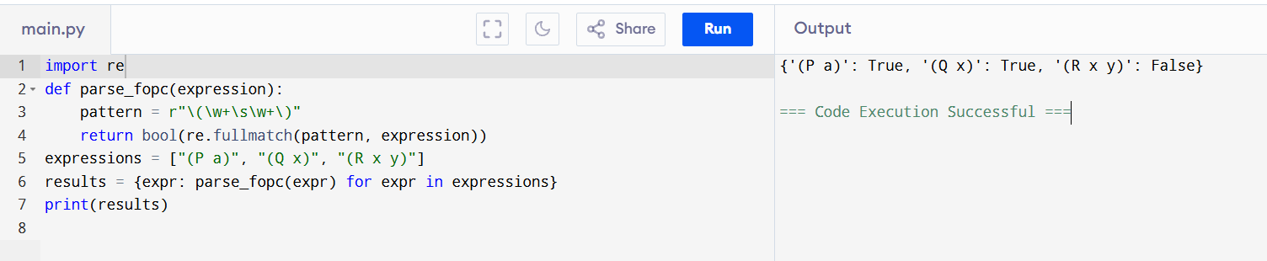

**Result:**  
The FOPC parser validates logical expressions successfully.